SUMMATIVE ASSESSMENT TEST

SECTION I - READING COMPREHENSION (30p)
Read the text.
Flamingos are tall and beautiful birds. They are pink or red and have got yellow eyes. They have got a long neck and long legs too.
Flamingos like water and live near lakes. Small fish are their favourite food. They can swim, fly and stand on one leg too. Flamingos have got one chick every year. The little baby flamingos are grey or white.

I. Read again and write. (5x2p=10p)
eyes pink long white bird

- A flamingo is a ____________.
- A flamingo is ____________.
- It has got yellow ______________.
- A flamingo’s legs are ______________.
- A baby flamingo is grey or ____________. .

II. Answer the following questions: (5x4p=20p)
- Is the flamingo tall?
- What colour is it?
- What do flamingos eat?
- Can flamingos stand on one leg?
- What colour are baby flamingos?

SECTION II - GRAMMAR AND VOCABULARY (40p)
1. Look at the pictures and underline the correct word. (10x1p=10p)
1. pen / pencil 2. hat / cap 3. 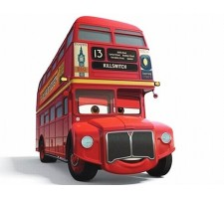 bus / train 4. dress / skirt 5. 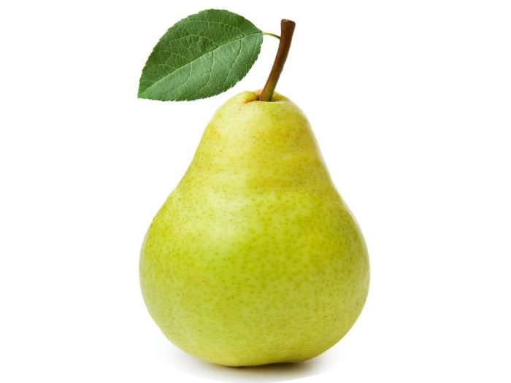 pair / pear 6. 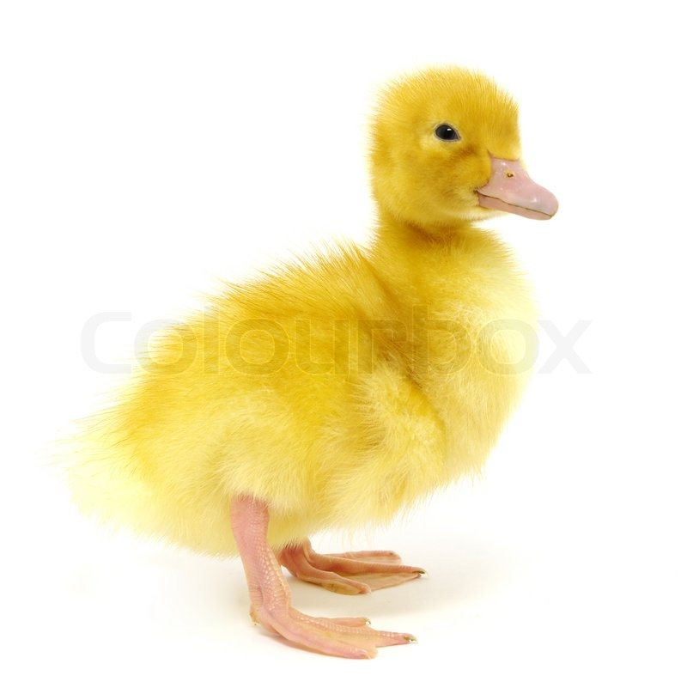duck / chicken 7. tree / three 8. floor / flower
9.  plain / plane 10. table / desk

2. Choose the correct answer. (10x1p=10p)
1. What numbers are these? Two, five, eight, twelve
A. 3, 5, 8, 10 B. 2, 5, 8, 12 C. 2, 3, 8, 12
2. At Halloween children put on scary costumes and say ..............................!
A. Trick or cheat B. Trick or treat C. Check or treat
3. It’s one o’clock in the afternoon. It’s time for ............................... .
A. breakfast B. lunch C. dinner
4. Potatoes, carrots and ......................... are vegetables.
A. grapes B. honey C. tomatoes
5. There are ten.................... in the basket.
A. strawberry B. strawberries C. strawberrys
- Kate can ...................... the guitar.
A. play B. sing C. do
- I am wearing a yellow ...................... .
A. tree B. picture C. T-shirt
- Giraffes ..................... long necks.
A. has got B. have got C. are got
- The birds ..................... singing in the tree.
A. is B. am C. are
- There aren’t ........................ eggs in the fridge.
A. some B. any C. no
3. Write the words in the correct order. (5x1p=5p)
- is / Where / teddy / my / bear?
- your / What / name / is ?
- ball / is / Tom’s / yellow/ chair / the / under.
- the / Close / please / door!
- can / A / bird / speak / cannot / but / fly / it.
4. Look, read and circle. (5x1p=5p)
1.The kite is in / on the bed.
2.The doll is under / on the chair.
3.The lamp is in / next to the book.
4.The teddy is in / on the car.
5.The book is near / between the lamp and the pencilcase.
5. Circle the mistake in each sentence. (5x2p=10p)
1.Sit up, please!
2.This is my friend. His name is Kate.
3.What old are you?
4.There are two horses at the farm.
5. A bee is a insect.
SECTION III- WRITING (20p)
Write five sentences about what you can do and five sentences about what you can’t do.

