SUMMATIVE ASSESSMENT TEST

SECTION I - READING COMPREHENSION (30p)
A Brief History of Pizza
It’s kind of silly to talk about the moment when pizza was ‘invented’. It gradually evolved over the years but one thing’s for certain - it’s been around for a very long time. The idea of using pieces of flat, round bread as plates came from the Greeks. They called them ”plakuntos” and ate them with various simple toppings such as oil, garlic, onions, and herbs. The Romans enjoyed eating something similar and called it ”picea”. Around 1000 AD in the city of Naples, ”picea” became pizza and people started adding more toppings: cheese, ham, fish, and finally the tomato, brought to Italy from Mexico and Peru in the 16th century.
Naples became the ”pizza capital” of the world. In 1889, King Umberto I and Queen Margherita heard about pizza and asked to try it. They invited pizza maker, Raffaele Esposito, to make it for them. He decided to make the pizza like the Italian flag, so he used red tomatoes, white mozzarella cheese, and green basil leaves. The Queen loved it and the new pizza was named ‘Pizza Margherita’ in her honour.
Pizza migrated to America with the Italians at the end of the 19th century. The first pizzeria in the United States was opened in 1905 in New York City, by Gennaro Lombardi. Americans are now the greatest producers and consumers of pizza in the world.

- Answer the questions (Give long answers) (5x4p=20p)
- What year did ”picea” become pizza?
- Which came first: ”picea” or ”plakuntos”?
- Why are Mexico and Peru important in the development of pizza?
- Which town is the ”pizza capital” of the world?
- Who opened the first pizzeria in the USA?
- Find in the text: (10x1p=10p)
- 5 words referring to pizza toppings;
1.…………… 2. …………... 3. …………..... 4. ……………… 5. ...........................
- the name of one type of pizza;
.……………
- 4 words denoting nationalities;
1.……………… 2. …………… 3. ……………...... 4. .............................
SECTION II - GRAMMAR AND VOCABULARY (40p)
Exercise 1. Circle and write the correct word: (10px1p=10p)
- My brother plays football _______ .
- good B. goodly C. well
- Do the boys like_______ to rap music?
A. listening B. listen C. listens
3. I think chocolate ice cream is _______ than coffee ice cream.
A. tasty B. tastier C. much tasty
4. Their _______ names are Ben and Tom.
A. father’s B. fathers’ C. fathers’s
5. Who _______ coffee yesterday morning?
A. did make B. made C. maked
6. She usually goes to work _______ foot.
- on B. by C. at
7. You buy _______ at the butcher’s .
A. bread B. oil C. pork sausages
8. Bill Gates is the _______ man in the USA.
A. rich B. most rich C. richest
9. The children_______ to go to the beach.
A. won’t B. want C. likes
10. Rebecca was at the party __________ .
A. last night B. yesterday night C. tonight

Exercise 2. Fill in with the correct prepositions. More than one answer is possible. (5x1p=5 p)
- There is a post office the bank. So you just have to cross the street to get there.
- He waited ___ an hour and then he left.
- The mouse jumped ________ the potato box.
- Your schoolbag is ________ the bed and the desk.
- Please wash your hands _______ dinner.

Exercise 3. Complete the phrases with the right word from the box (5x1p=5p)
does heart sheep only mouse

a) His parents are not proud of him. He is the black _______ of the family.
b) The new girl in our class never talks. She is as quiet as a _________ .
c) This woman has a ____________of gold. She is very generous.
d) Susan hasn’t got any brothers or sisters. She is an ______child.
e) He is a very good runner. He ______________ athletics twice a week.

Exercise 4. Correct the mistakes and write the sentences (5x1p=5p)

- They don’t go usually on holiday in May.
- Brian drinks tea yesterday morning.
- It is dangerous to drive fastly.
- I want he to help in the garden.
- Vegetables are healthier then meat.

Exercise 5. Complete each sentence with make or do. (5x1p=5p)

- Please, don’t …………….. so much noise!
- Don’t forget to …………. your homework before you go out.
- ”………..your bed!”, says mother every morning.
- My sisters ……….. the washing up in our house.
- These boys ………..karate at the Sports Centre at the weekends.

Exercise 6. Put the verb into the correct form, present simple (I do), present continuous (I am doing), or past simple (I did). (5x2p=10p)

  - Mary (not talk) on the phone at the moment.
  - Jacob Davis and Levi Strauss (make) the first jeans in 1923.
  - What languages (you/study) at school?
  - Listen! Someone (play) the violin.
  - When (you/be) born?

SECTION III - WRITING (20p)
A.Do the crosswords. (16 points)
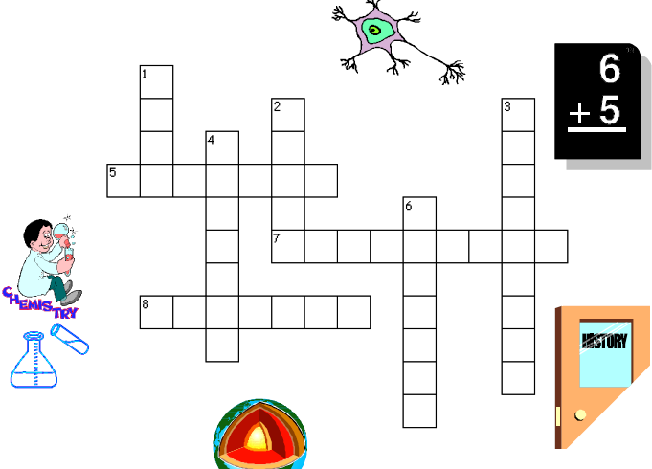

Clues Across
5. It is a subject about the language of China._____________
7. This is a science subject with lots of chemical experiments.___________
8. It is a subject that teaches us about past events._______________

Clues Down
1. When we study ________, we study numbers.
2. We can learn to sing and play the piano when we study__________
3. We learn about countries, maps & places in the world when we study
___________
4. It is a language subject that teaches us the language of England.
6. We can learn about plants and animals in _______________.

B.What’s your favourite school subject? Why? (4 points)

ANSWER SHEET
Allowed time: 120 minutes
SECTION I READING COMPREHENSION (30p)
A) 5 x 4p = 20 points
- ”Picea” became pizza around 1000 AD.
- ”Plakuntos” came first.
- Mexico and Peru are important in the development of pizza because the tomato was brought from these countries / because people brought the tomato from Mexico and Peru.
- Naples is / became the ”pizza capital” of the world. / The town which is the ”pizza capital” of the world is Naples.
- Gennaro Lombardi opened the first pizzeria in the USA. / The first pizzeria in the USA was opened by Gennaro Lombardi.
B) 10 x 1p = 10 points
- oil, garlic, onions, herbs, cheese (ham, fish, tomato);
- Pizza Margherita;
- the Greeks, the Romans, the Italians, Americans.

SECTION II GRAMMAR AND VOCABULARY (40p)
Exercise 1. 10 x 1p = 10 points
1. C (well) 2. A (listening) 3. B (tastier) 4. B (fathers') 5. B (made) 6. A (on) 7. C (pork sausages) 8. C (richest) 9. B (want) 10. A (last night)
Exercise 2 5x1p=5 points
1. next to/ near/ opposite/ in front of/behind
2. for
3. out of/into/on
4. between
5. before/after/for
Exercise 3. 5x1p=5 points
a) sheep b) mouse c) heart d) only e) does
Exercise 4. 5x1p=5 points
- They don’t usually go on holiday in May.
- Brian drank tea yesterday morning.
- It is dangerous to drive fast.
- I want him to help in the garden.
- Vegetables are healthier than meat.
Exercise 5. 5x1p=5 points
1. make 2. do 3. Make 4. do 5. do
Exercise 6. 5 x 2p = 10 points
a. is not talking / isn't talking / 's not talking
b. made
c. do you study / did you study
d. is playing / 's playing
e. were you born
SECTION III - WRITING (20p)
A. 8x2p=16 points
1. Math 2. Music 3. Geography 4. English
5. Chinese 6. Biology 7. Chemistry 8. History
B. 4 points (2 points -stating the favourite school subject; 2 points-giving the reasons for choosing that particular subject)

BONUS POINTS: 10 points

