LESSON PLAN
CURRICULUM ARIA: Mathematics and Sciences
SUBJECT: Chemistry
CLASS: VII
TEACHER: PhD. Macovei Ada Alexandrina
UNIT OF LEARNING: Corp. Substance. Mixture
TOPIC: Pollution of water, air and soil
TYPE OF LEARNING: Consolidation and systematization of knowledge

GENERAL AND SPECIFIC COMPETENCES:
5. Assessing the consequences of chemical processes and the action of chemicals on humans and on environment.
• applying the personal safety rules in the Chemistry lab and the environment protection measures;
• assessing the risk factors and recognizing the importance of certain chemical species;
• assessing the risk factors resulting from putting into practice certain chemical reactions and recognizing their importance.

OPERATIONAL OBJECTIVES:
O1 - to identify causes of pollution and their consequences on environment and humans;
O2 - to recognize different types of pollution;
O3 - to exemplify various polluting materials and substances;
O4 - to collect selectively;
O5 - to know and apply the measures of preventing environmental pollution;
O6 - to use language elements specific to the topic.

TEACHING STRATEGIES:
a) Procedural resources: directed dialogue, observation, explanation, deductive discovery, the gallery walk;
b) Material resources: Ppt presentation, posters, flyers, displays;
c) Informational resources: computer, video projector, Internet access.
(Bibliography: Fatu Sanda, Stroe Felicia and Stroe Constantin, Chemistry textbook, 7th grade, Corint Publishing House, 1999)

CONTEXT: The activity takes place in the Chemistry lab, with the whole class, within the Chemistry Teachers Meeting.
Content of the teaching process | Assessment
Students prepare themselves for the lesson;  The guests are introduced and it is explained the purpose of their presence;  The objectives of the lesson are presented to the students;  Brief revision of the knowledge previously acquired (the clusters on the board);  1. The soil:  - dumping garbage at random;  - chemical fertilizers in agriculture;  - detergents and other chemicals;  - insecticides used against pests;  - acid rains;  - industrial accidents;  - rotting animals;  - fires;  - agricultural and industrial waste.  2. Water:  - polluting substances brought by soil washing;  - animal and vegetable scraps;  - household water discharged into flowing water;  - ship oil spills (into the Black Sea);  - spillage of industrial waste;  - hot water from thermal power stations  3. Air:  - gases;  - smoke;  - dust;  - ash  4. Other types of pollution:  Sound pollution - pollution by strong noises of any nature.  Natural pollution: earthquakes, volcanoes, hurricanes, fires, floods, lightning, storms, winds.  Homework checking;  Presentation of the posters made by the students;  Gallery display  Conclusions: The students have seen the causes and effects of environmental pollution, now they are asked to find several ways in order to protect the environment:  • learn how to keep it clean and teach others, too;  • not to break the plants, but to plant as many as possible;  • not to throw away waste at random;  • not to make big noise;  • collect selectively;  • not to cause fires, etc.  Assessment;  Presenting the topic of the next lesson;  Information dissemination: the students distribute flyers on the topic of the lesson in school; | Observation of students' interest  Short-term evaluation  Formative assessment through practical tasks  Oral formative assessment  Individual assessment  Global assessment

The Cluster

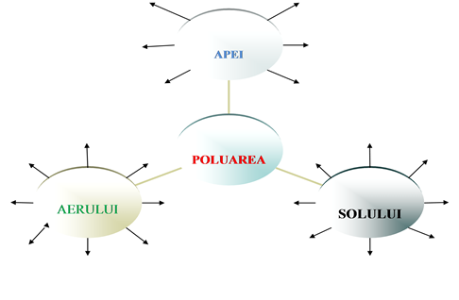
WATER
SOIL
AIR
POLLUTION

